GET DATA
/TYPE=XLSX
/FILE='C:\Users\efilguer\Downloads\Soccer Data.xlsx'
/SHEET=name 'Soccer_FullData'
/CELLRANGE=FULL
/READNAMES=ON
/DATATYPEMIN PERCENTAGE=95.0
/HIDDEN IGNORE=YES.
EXECUTE.
DATASET NAME DataSet1 WINDOW=FRONT.
GRAPH
/BAR(GROUPED)=PCT BY Preffered_Foot BY Weak_foot.

Graph

Notes
Output Created |  | 18-FEB-2019 14:26:27
Comments
Input | Active Dataset | DataSet1
Input | Filter | <none>
Input | Weight | <none>
Input | Split File | <none>
Input | N of Rows in Working Data File | 17588
Syntax |  | GRAPH  /BAR(GROUPED)=PCT BY Preffered_Foot BY Weak_foot.
Resources | Processor Time | 00:00:00.52
Resources | Elapsed Time | 00:00:00.88

[DataSet1]

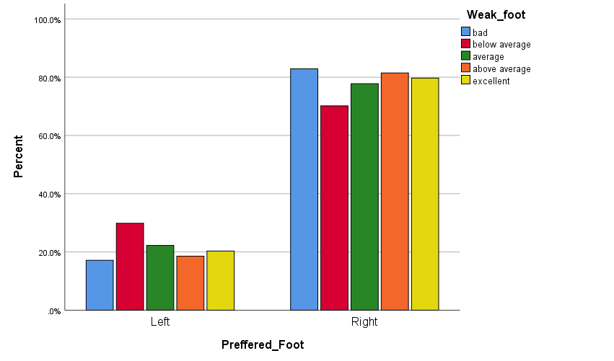

GRAPH
/BAR(GROUPED)=PCT BY Weak_foot BY Preffered_Foot.

Graph

Notes
Output Created |  | 18-FEB-2019 14:26:53
Comments
Input | Active Dataset | DataSet1
Input | Filter | <none>
Input | Weight | <none>
Input | Split File | <none>
Input | N of Rows in Working Data File | 17588
Syntax |  | GRAPH  /BAR(GROUPED)=PCT BY Weak_foot BY Preffered_Foot.
Resources | Processor Time | 00:00:00.23
Resources | Elapsed Time | 00:00:00.21

